Name: | _______________________________________________ |  |  | Date: ___________
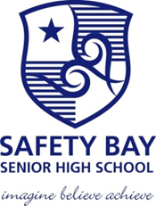 | Year 8 Mathematics SBSHS  Diagnostic Test, 2015  Topics – Number and Algebra, Measurement and Geometry, Statistics and Probability. |  |  | 37  = %
Total Time: | 40 minutes | Equipment Allowed: Pens, pencils, eraser, ruler. |  |  | Nil
Weighting: | ______% of the year.
SECTION 1: CALCULATOR FREE

- 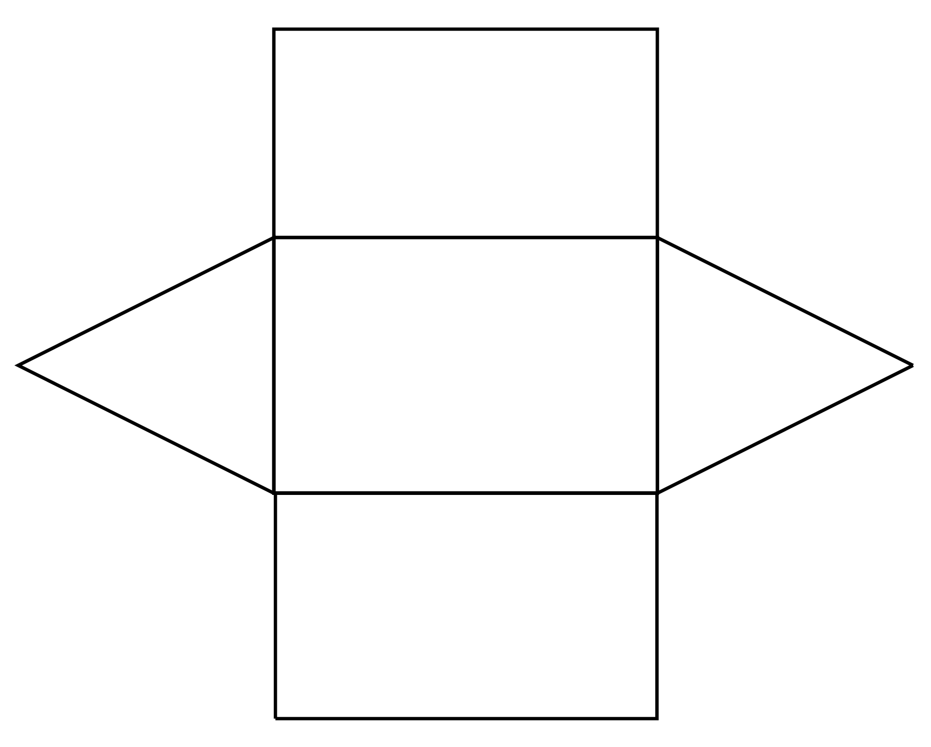Draw a three dimensional sketch of the prism whose net is shown below. (2 marks)

- What is the area of a rectangle 5cm by 6cm? (1 mark)
5cm | 12 cm | 30 cm² | 30 cm | 12 cm²

Show how you worked out you answer / justify your answer. (2 marks)
- What is the perimeter of a rectangle 4cm by 7cm? (1 mark)
11 cm | 22 cm | 35 cm² | 30 cm | 12 cm²

Show how you worked out you answer / justify your answer. (2 marks)

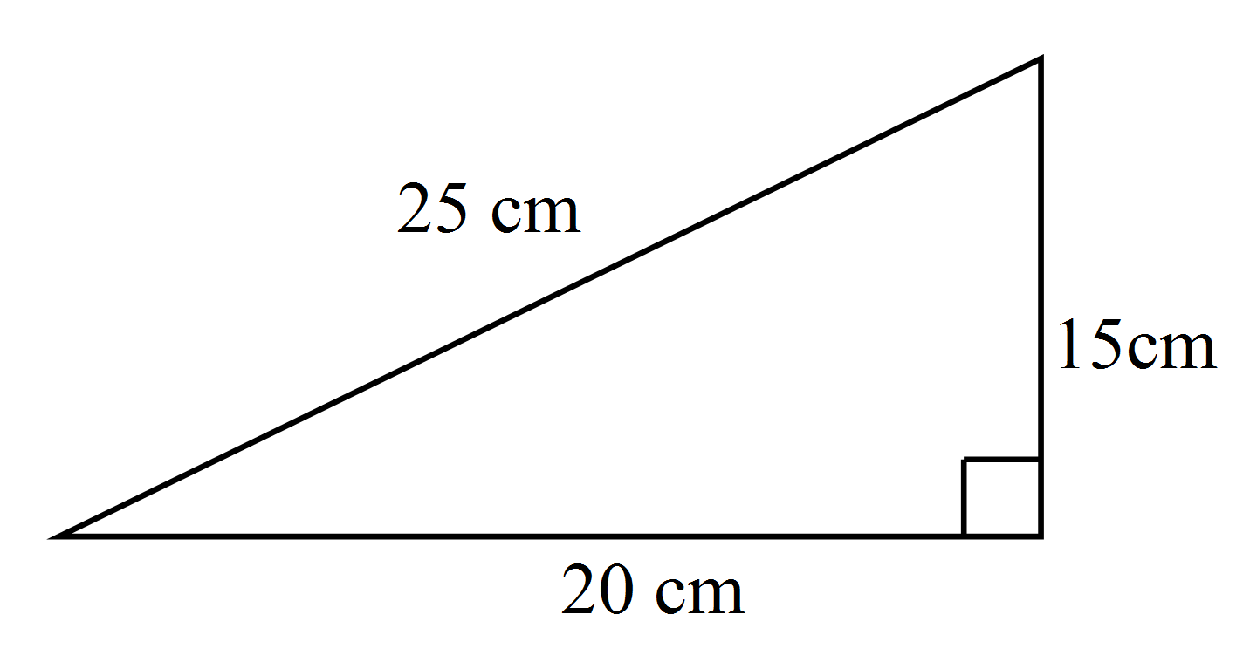
- What is the area of the triangle? (1 mark)

150 cm | 220 cm | 150 cm² | 345 cm | 400 cm²

Show how you worked out you answer. (2 marks)

- Calculate: (4 marks)
a) | 1.607 + 1.02 | b) | 12.231 – 8.026
c) | 14 × 0.6 | d) | 5768 ÷ 8

- Which is not equal to 24%? (1 mark)
0.24 |  |  |  | 24%

- Jade buys a 200 gram bag of beads at a market. Each bead weighs 0.48 grams.
Which of these is the best estimate for the number of beads in the 200 gram bag? (1 marks)
400 | 200 | 50 | 4 | 150

Show how you worked out you answer. (2 marks)

- The four shapes below are made using 1 cm square tiles. Which of the shapes has the greatest perimeter? (1 mark)
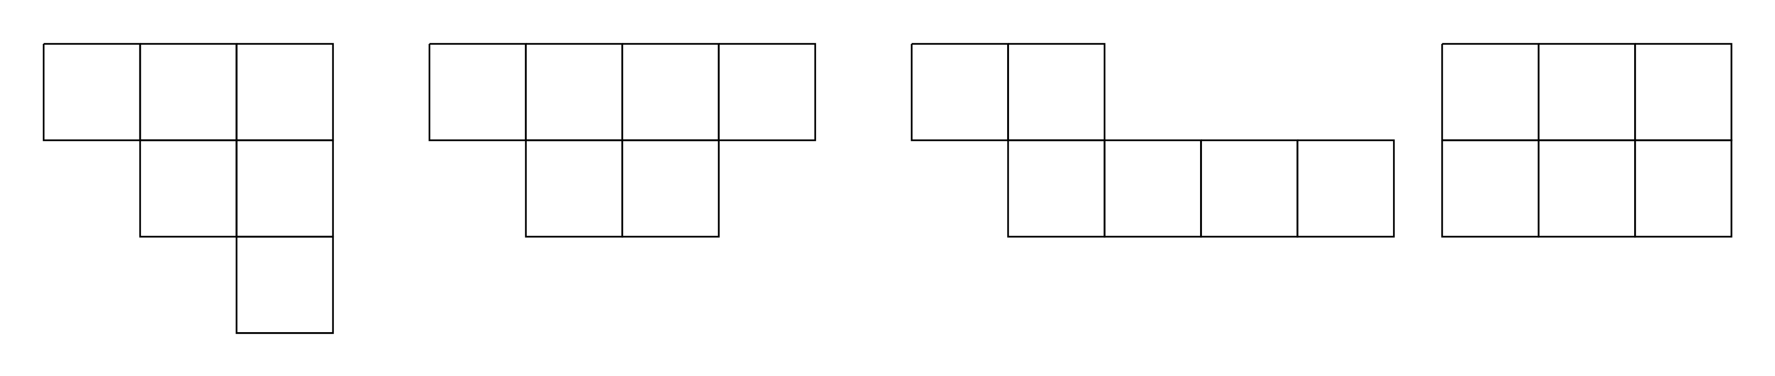

- I went to McDonalds and I bought 4 burgers and 3 drinks and it cost $26.
How could you represent this without using words? (2 marks)

- From the above question, if a burger costs $5, how much would a drink cost?

Show how you worked out you answer. (2 marks)

- Calculate: (4 marks)
a) | Round 247 to the nearest hundred. | b) | Round 563 to the nearest ten.
c) | Double 437. | d) | What is a half of 348.

- Calculate each of the following by using BIMDAS: (4 marks)
a) | 5 - 3 x 8 = | b) | 24 – 15 + 3 =
c) | (2 + 3) x 4 = | d) | 16 ÷ 8 x 3 =
Colour
White
Number
Grey
7
9
Black
5
Red
4
- The table displayed alongside lists the colours of cars that Mike collected from the staff car park.
One of the cars is picked at random to receive a free car wash.

(5 marks)
a) | How many cars were in the car park?
b) | What is the probability that a white car is chosen for the free car wash?
c) | What is the probability that either a grey or white car is chosen?
d) | What is the probability of not choosing a red car?

